*DATA WAREHOUSE AND DATA MINING*

*ASSIGNMENT 6- Use any healthcare dataset (breast cancer, covid-19, diabetes prediction etc.) perform all three classification and compare the result*

*NAME- GARGI YEKHANDE*

*ROLL NO- 25*

*RANDOM FOREST*

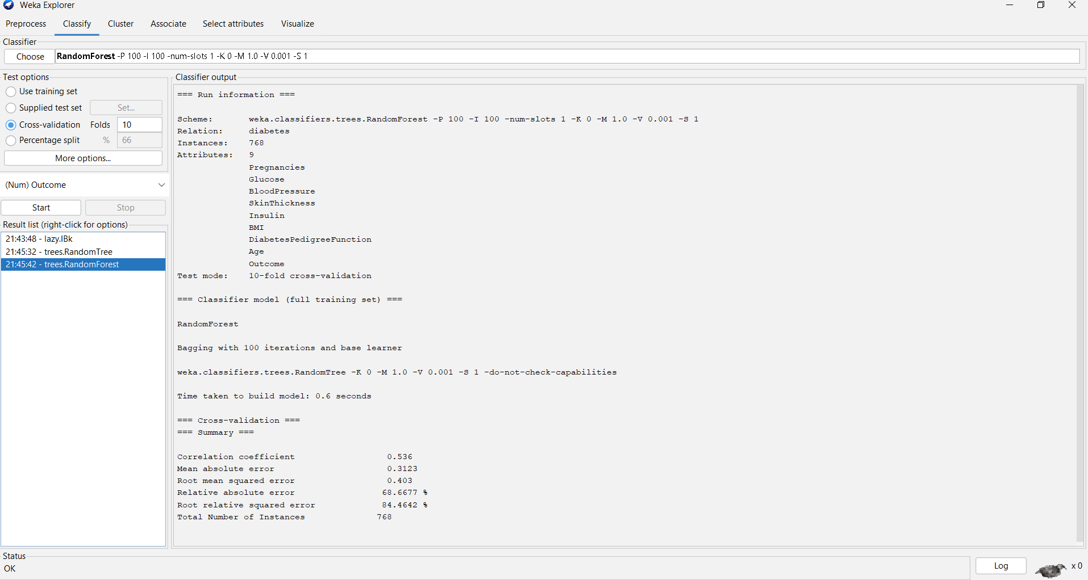

*NAÏVE BAYES*

A

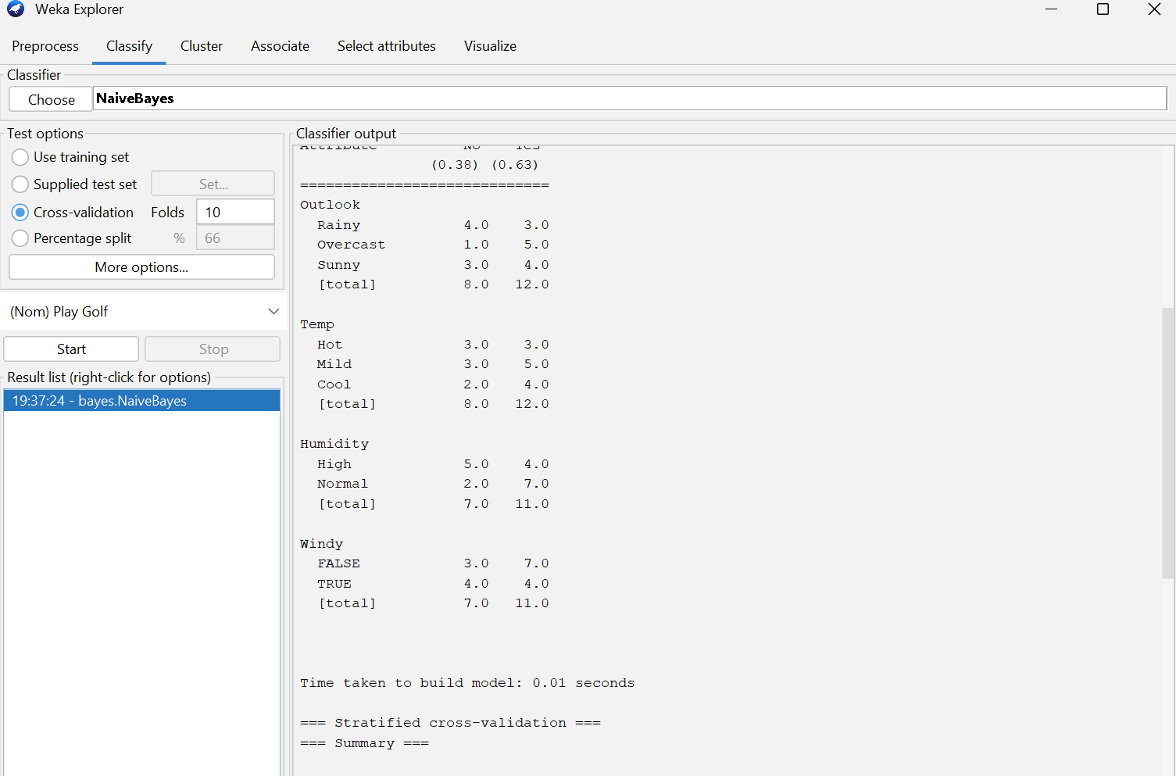

*KNN:*

*